1. **Database and Table Creation (Code and Results Interpretation)**

CREATE DATABASE world_bank_data;

USE world_bank_data;

**Explanation:** Creates a new database called ‘world_bank_data’ and sets it as the active database for subsequent operations.

-- Table 1 locations with location_id as the primary key

CREATE TABLE locations (

location_id INT PRIMARY KEY,

country VARCHAR(50),

countryiso3code VARCHAR(10),

region VARCHAR(50)

);

**Explanation:** This table stores information about each location (country), with location_id as the primary key. It includes columns for the country name, ISO3 code, and region. This serves as a foundational table for linking location data to other indicators.

-- Table 2 economic_indicators with indicator_id as primary key

CREATE TABLE economic_indicators (

indicator_id INT PRIMARY KEY,

location_id INT,

country VARCHAR(50),

date DATE,

gdp_usd DECIMAL(15,2),

gdp_per_capita_usd DECIMAL(15,2),

inflation_rate DECIMAL(5,2),

fdi_usd DECIMAL(15,2),

exports_gdp DECIMAL(5,2),

unemployment_rate DECIMAL(5,2),

unemployment_growth_rate DECIMAL(5,2),

gdp_growth_rate DECIMAL(5,2),

high_gdp TINYINT,

FOREIGN KEY (location_id) REFERENCES locations(location_id)

);

**Explanation:** Stores economic_indicators, such as GDP, inflation, FDI, and unemployment, with indicator_id as the primary key. The location_id serves as a foreign key, linking each record to the locations table.

-- Table 3 demographic_indicators with demographic_id as primary key

CREATE TABLE demographic_indicators (

demographic_id INT PRIMARY KEY,

location_id INT,

country VARCHAR(50),

date DATE,

population_total INT,

population_growth DECIMAL(5,2),

urban_population DECIMAL(5,2),

urbanization_rate_change DECIMAL(5,2),

life_expectancy DECIMAL(5,2),

child_mortality_rate DECIMAL(5,2),

primary_school_enrollment DECIMAL(5,2),

FOREIGN KEY(location_id) REFERENCES locations(location_id)

);

**Explanation:** Contains demographic data, including population growth, life expectancy, and urbanization rates, with demographic_id as the primary key. It’s linked to locations via location_id for cross-referencing.

-- Table 4 sustainable_indicators with sustainable_id as primary key

CREATE TABLE sustainable_indicators (

sustainable_id INT PRIMARY KEY,

location_id INT,

country VARCHAR(50),

date DATE,

access_electricity DECIMAL(5,2),

renewable_energy_consumption DECIMAL(5,2),

FOREIGN KEY (location_id) REFERENCES locations(location_id)

);

**Explanation:** This table #4 stores data related to sustainability, such as access to electricity and renewable energy consumption, with sustainable_id as the primary key. The location_id foreign key connects it to the locations table.

-- View a Sample of Data

SELECT * FROM economic_indicators LIMIT 10;

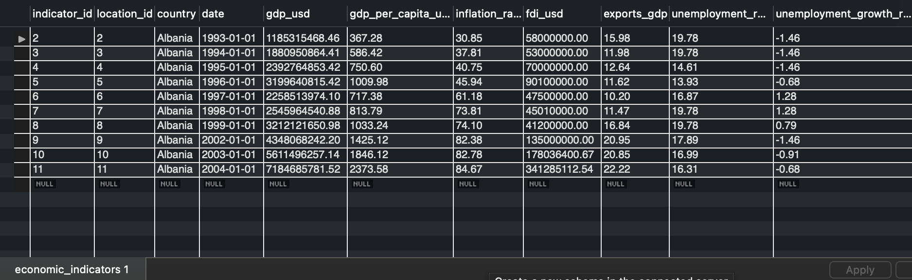

**Explanation:** Retrieves the first 10 rows from the economic_indicators table to display a sample of the data for verification and inspection purposes.

-- Countries with the Highest GDP Growth Rate

SELECT country, date, gdp_growth_rate

FROM economic_indicators

ORDER BY gdp_growth_rate DESC

LIMIT 100;

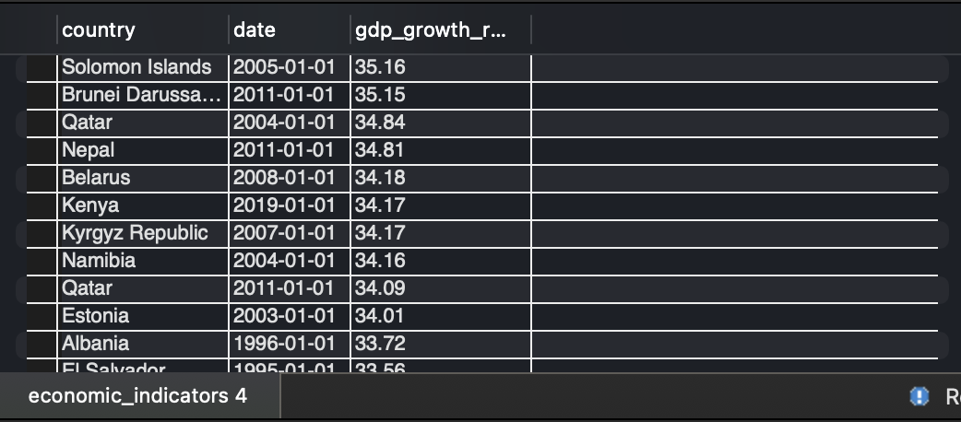

**Explanation:** This query lists the top 10 countries with the highest GDP growth rate, providing insight into the fastest-growing economies based on the data available.

-- Count the Number of Records per Country

SELECT country, COUNT(*) AS record_count

FROM economic_indicators

GROUP BY country

ORDER BY record_count DESC;

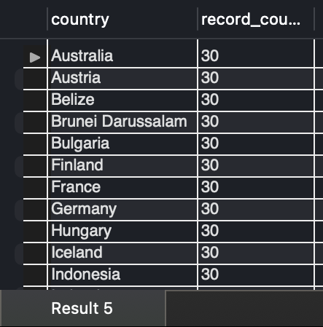

**Interpretation:** This query counts the number of records for each country in the economic_indicators table. This helps identify which countries have more data points, indicating a richer dataset for those regions.

-- Top 10 Countries with the Highest Renewable Energy Consumption

SELECT country, renewable_energy_consumption

FROM sustainable_indicators

ORDER BY renewable_energy_consumption DESC

LIMIT 10;

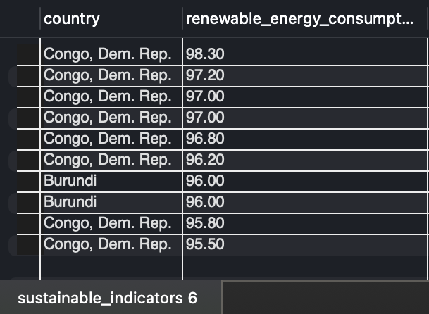

**Interpretation:** Retrieves the top 10 countries with the highest renewable energy consumption, highlighting the leaders in renewable energy usage.

-- Average Unemployment Rate by Year

SELECT YEAR(date) AS year, AVG(unemployment_rate) AS avg_unemployment

FROM economic_indicators

GROUP BY year

ORDER BY year;

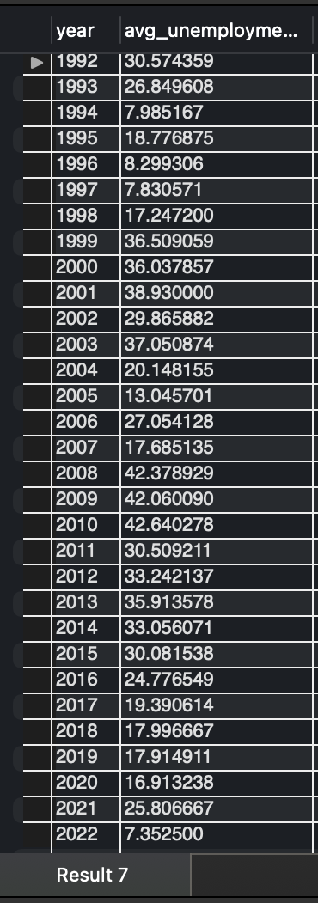

**Interpretation:** Calculates the average unemployment rate per year across all countries. This provides a trend analysis of global unemployment rates over time, offering insights into economic stability and labor markets.